Excel Assignment - 10

1. See the below picture and create the exact table with exact formatting. Font – ‘Times New Roman’ Size – 14, Color of first line Orange.

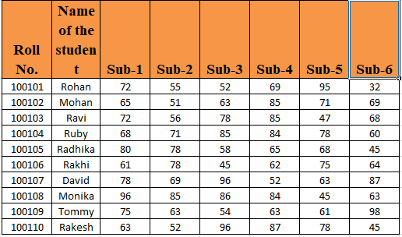

1. From the above table use Sum Formula and find the total for each student.

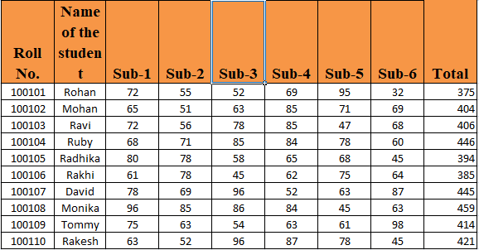

1. Calculate Average for each student in the next row. Use Formulas.

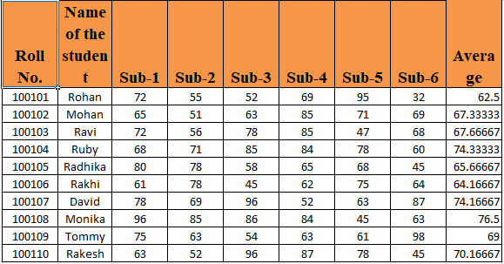

1. Calculate Rank for each student. Use Formulas.

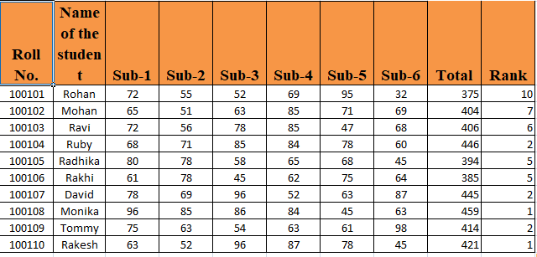

5. Calculate Percentage for each student. Use Formulas. Round off the decimals up to 2 points.

